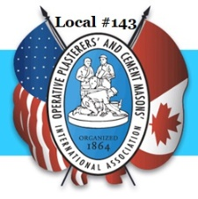 | OP&CMIA Local #143  Update Member Information  Request

Member Information

Personal Information
Full Name:
 | Last | First | M.I.

Address:
 | Street Address | Apartment/Unit #

 | City | State | ZIP Code

Home Phone: |  | Alternate Phone:

Email

Birth Date: |  | Marital Status:

Spouse’s Name:

Beneficiary : ______________________________________________________________________________

Emergency Contact Information
Full Name:
 | Last | First | M.I.

Address:
 | Street Address | Apartment/Unit #

 | City | State | ZIP Code

Primary Phone: |  | Alternate Phone:
Relationship:

